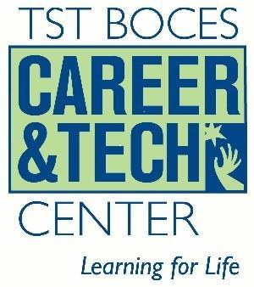

Code | Program Name | TST
460201 | Carpentry/Carpenter | A(Approved)
460302 | Electrician | A
480508 | Welding Technology/Welder | A
470302 | Heavy Equipment Maintenance Technology/Technician | A
470603 | Auto body/Collision and Repair Technology/Technician | A
470604 | Automobile/Automotive Mechanics Technology/Technician | A
119999 | Computer and Information Sciences and Support Services, Other | A
120401 | Cosmetology/Cosmetologist, General | A
120599 | Culinary Arts and Related Services, Other | A
511614 | Nurse/Nursing Assistant/Aide and Patient Care Assistant | A
190709 | Child Care Provider/Assistant | A
500409 | Graphic Design | A
430107 | Criminal Justice/Police Science | Not Yet Approved

